 **Fake Agoda App**

**Database Design Document (DDD)**

**Version 1.0**

**Prepared by: *Lagmay, Sarah Margaret***

***Estabillo, Ma. Elaine***

**Revision History**

| **Date** | **Version** | **Description** | **Author** |
| --- | --- | --- | --- |
| 03–03-25 | 1.0 | Database design document | Lagmay, Estabillo |
| 03-04-25 | 1.0 | Minor changes on the ERD and Conceptual Diagram | Lagmay, Estabillo |

Table of Contents

**1** **Introduction 1**

1.1 Document Objectives 1

1.2 Intended Audiences 1

**2** **Entity Relationship Diagram 1**

**3** **Detailed Database Design 2**

*3.1.1* *Data dictionary 2*

3.1.1.1 Data dictionary for Element: Users/Guest Table 2

3.1.1.2 Data dictionary for Element: Reservations Table 2

3.1.1.3 Data dictionary for Element: Hotel Table 3

3.3.1.4 Data dictionary for Element: Rooms Table 3

3.2 MySQL database design (Relational database) 4

*3.2.1* *Conceptual diagram* 4

*3.2.2* *Description* 4

*3.2.3* *Purpose of Tables* 5

3.2.3.1 Purpose of Users/Guest Table 5

3.2.3.2 Purpose of Reservations Table 5

3.2.3.3 Purpose of Hotel Table 5

3.2.3.4 Purpose of Room Table 5

*3.2.4* *Relations* ………………………………………………………………………………………….5

# Introduction

This Fake Agoda App is an attempt to create a program that allows different room/property rental businesses to market their properties and users to easily find and book a property for their travel. This program aims to illustrate the schema of a property booking app and its database.

## Document Objectives

This DDD for the Agoda software has the following objectives:

* Describe the design of a DynamoDB and SQLite database, that is, a collection of related data stored in one or more computerized files in a manner that users or computer programs can access via a database management system (DBMS). It can also describe the software units used to access or manipulate the data.
* To serve as the basis for implementing the database. It provides the acquirer visibility into the design and provides information needed for software support.

## Intended Audiences

This DDD is intended for the following audiences:

* Business owners who aims to establish a hotel booking business
* Developers including:
* Architects, whose overall architecture design must meet the requirements specified in this document.
* Designers, whose design must meet the requirements specified in this document.
* Developers, whose software must implement the requirements specified in this document.
* Quality Assurance personnel, whose test cases must validate the requirements specified in this document.

# Entity Relationship Diagram

# Detailed Database Design

This section describes the actual design of different databases at varying levels of abstraction. A subsection for each of conceptual, internal, logical and physical levels.

### Data dictionary

#### Data dictionary for Element: Users/Guest Table

| **Name** | **Data Type** | **Constrain** | **Description** |
| --- | --- | --- | --- |
| **CustomerID (primary key)** | Int | Min :1, Max:1 | Unique numerical identifier of the guest |
| **EmailAddress (primary key)** | String | Min :1, Max:1 | Email of the guest |
| **FirstName** | String |  | First Name of the guest |
| **LastName** | String |  | Last Name of the guest |
| **PhoneNumber** | Int |  | Phone number of the guest |

#### Data dictionary for Element: Reservations Table

| **Name** | **Data Type** | **Constrain** | **Description** |
| --- | --- | --- | --- |
| **ReservationNumber (primary key)** | Int | Min :1, Max:1 | A number that is assigned to the guest |
| **Email (foreign key)** | String | Min :1, Max:1 | Unique identifier of the guest |
| **HotelCode (foreign key)** | Int | Min :1, Max:1 | Unique numerical identifier assigned to a hotel |
| **CheckInDate** | Date |  | The date on which the guest are scheduled to arrive at the hotel |
| **CheckOutDate** | Date |  | The date on which the guest are expected to leave the hotel |
| **RoomType (foreign key)** | String |  | Describes the characteristics of a hotel room |
| **TotalCharge** | Int |  | The final amount a guest owes for their stay |

#### Data dictionary for Element: Hotel Table

| **Name** | **Data Type** | **Constrain** | **Description** |
| --- | --- | --- | --- |
| **HotelName** | String |  | Given name of the hotel |
| **HotelCode (primary key)** | Int | Min :1, Max:1 | Unique numerical identifier assigned to a hotel |
| **Location** | String |  | Specific place where the hotel can be found |
| **Rating** | Int |  | Assessment of the hotel |

#### 3.3.1.4 Data dictionary for Element: Rooms Table

| **Name** | **Data**  **Type** | **Constrain** | **Description** |
| --- | --- | --- | --- |
| **RoomNumber (primary key)** | Integer |  | Unique numerical identifier assigned to a room |
| **RoomType** | String |  | Describes the characteristics of a hotel room |
| **RoomPrice** | Double |  | Specifies the price of the room type |

## MySQL database design (Relational database)

### Conceptual diagram

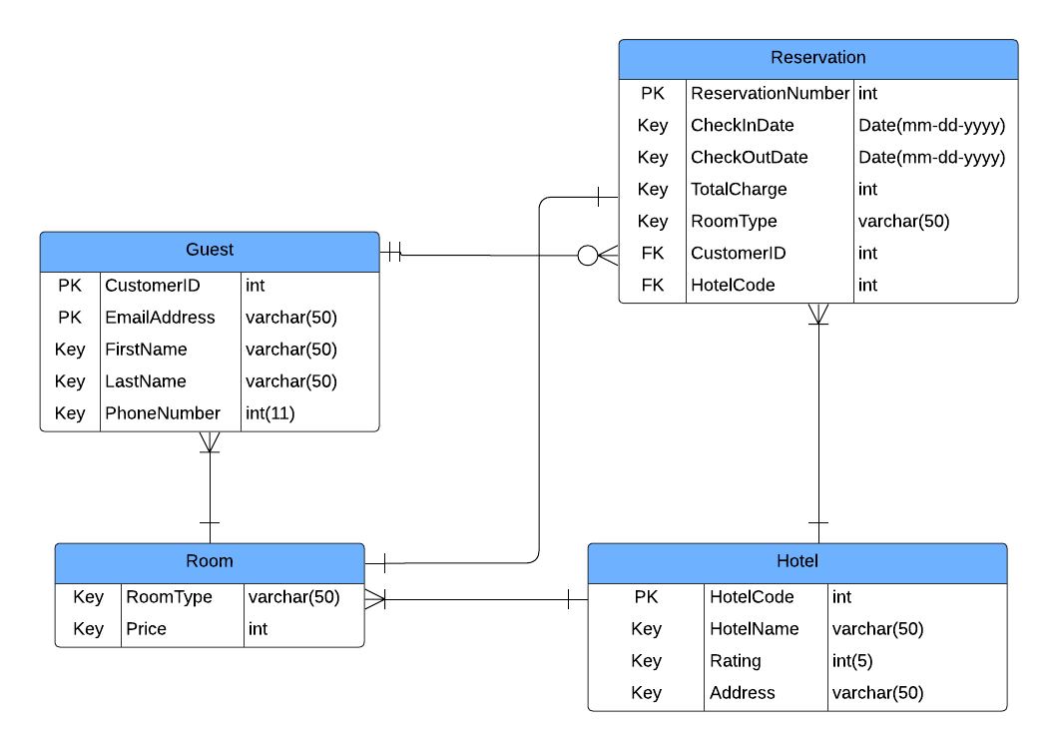

### Description

This diagram displays the conceptual model of the SQL database. This database will be created after it has imported the user’s data. An individual can create an account by inputting a valid name, an email and a phone number that has not yet been used and a password. Each user can create zero or more reservations and can manipulate their data with an update and deletion feature.

### 

### Purpose of Tables

#### Purpose of Users/Guest Table

This table stores the information of the guest. When an individual signs up, the information they inputted for their account will be stored in this table. The user's information is secured from other users and is only accessible by the admins.

#### Purpose of Reservations Table

This table stores all the information that the registered user will be submitting through a booking form which includes their chosen property, their reservation number, their contact information, and a check in and check out date. This file will be secured and only be accessed by the person who submitted their reservation, the admins, and the property owners or managers.

#### Purpose of Properties Table

Properties and its information, particularly the property name, property code, address, rating are stored in this table. This list can be accessed by admins, the admins may add, update, or delete a property and browsed by users wherein they can submit a reservation for their chosen property.

#### Purpose of Room Table

The purpose of this table is to identify and calculate the total charge of each user per their reservation. This table holds information about what type of room each property offers and specifies the price of each type.

### Relations

| **From Table** | **To Table** | **Relation** |
| --- | --- | --- |
| Users/Guest | Reservation | The guest submits a reservation. |
| Reservations | Hotel | Through reservations, guests can secure a hotel room. |
| Room | Users/Guest | Rooms contain a guest. |
| Hotel | Rooms | The Hotel offers a room for the guest |

# 